Advertising Project
Student’s Name
Institution
Course
Professor’s Name
Date

Advertising Project
From my visitation on Facebook for a week, I noticed that there are ads on my page. Some of these ads were engaging, while others were not. The engaging ads included coronavirus updates, which was informative because I did not get enough time to follow every bit of news regarding the pandemic. These ads increased my awareness of ways to prevent coronavirus and also detect the symptoms. When the pandemic started in early 2020, different contradictory information emerged, especially on the management of coronavirus. It was confusing, especially for someone who does not know anything about the pandemic. Informing ads like the WHO and CDC have gone a long way in preventing more harm from misinformation spread on Facebook and other social networking platforms. Some other ads like products from social marketing websites such as Alibaba kept on coming up on my page. While some of them were engaging as well as because of the content, they were also infuriating because they constantly appeared despite unsubscribing from the notifications.
Many other ads appeared on my home page, especially those I have highlighted in the above paragraph. However, others appeared on the subpages. For example, after logging in on the home pages of my Facebook account, I instantly received an ad on coronavirus update. However, this was just a link that requires me to click so that it takes me to the actual page of the World Health Organization, which contains the information about the pandemic. I once clicked on the link, and it took me to a detailed page where there was information about the pandemic, from the risk factors to deal with the coronavirus. On the other hand, there were also ads that appeared on the subpages. For example, when I opened my messages, commercial ads appeared, including Amazon and Alibaba’s ads. The difference with the previously discussed ad that appeared on my home page is that these ads that appeared in the subpages were not only links but some of the included product images.
There were also some similarities, especially that some ads repeatedly appeared in both home pages and subpages. For example, the Alibaba ads kept on appearing on the subpages as well as the home page. There are different reasons why the ads may have appeared on my page. For the World Health Organization ad that appeared on my home page, the reason may be that they have a contract with the Facebook company to advertise the information. For the commercial adverts like Alibaba and Amazon, I think it is because I visited the sites recently. Therefore, Google may be suggesting the information based on my search history because they only pop up when I am using my computer and chrome browser, to be precise.
At first, commercial websites such as Amazon suggested products that I had searched for. But later, it was suggesting even those that I had no interest in at all—the same with Alibaba ads. There are ads like the one about the coronavirus pandemic that I identified with. With the current age of technology, there is fake news spread through the social networking platforms like Facebook. It is important that we find credible, authentic, and reliable information. Ads like the WHO’s, the videos, and links to detailed articles placed on Facebook help reduce the spread of fake news and promote awareness about the pandemic regarding coronavirus. As a new pandemic, there are different theories and unauthenticated information about how to deal with it. Therefore, getting accurate information from reliable sources like the WHO is safe for users of these social networking sites.

Screenshot
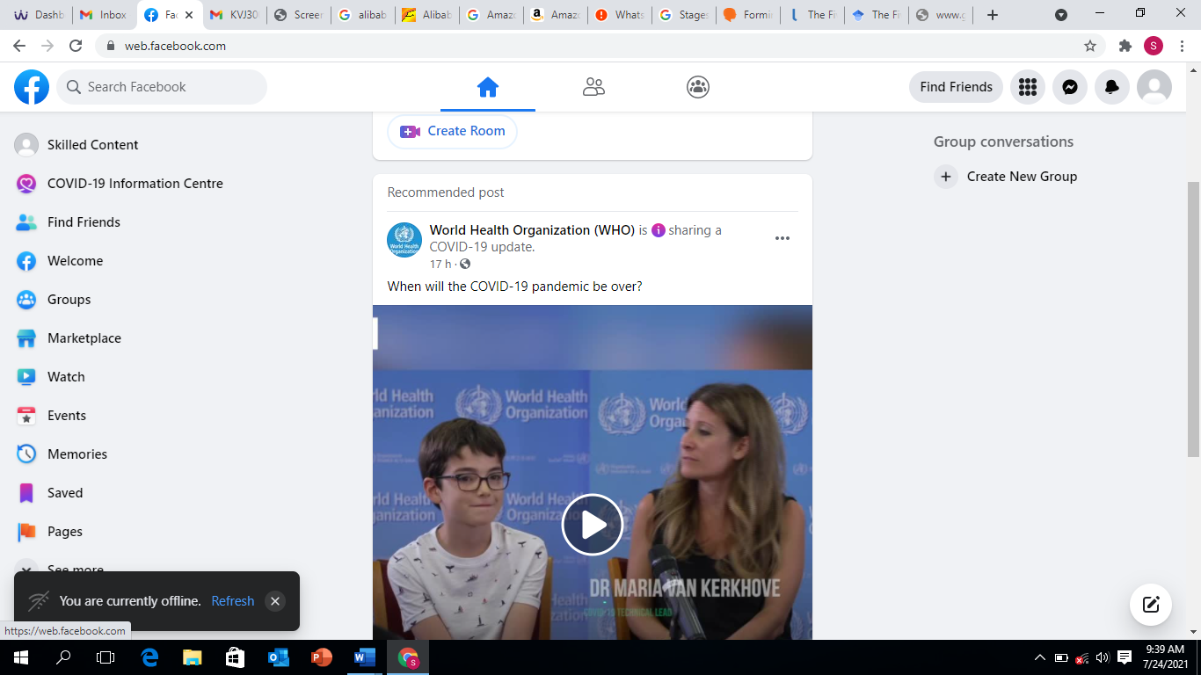
Screenshot on Facebook Homepage

